Section I: Scenario Demographics

Scenario Title: | Elder Abuse
Date of Development: | (30/04/2018)
Target Learning Group: | Juniors (PGY 1 – 2) Seniors (PGY ≥ 3) All Groups

Section II: Scenario Developers

Scenario Developer(s): | Dr. Rebecca Shaw, Dr. Nemat Alsaba, Dr. Victoria Brazil
Affiliations/Institution(s): | The Gold Coast University Hospital, Gold Coast, Australia
Contact E-mail (optional): | Rebecca.shaw2@health.qld.gov.au

Section III: Curriculum Integration

Learning Goals & Objectives
Educational Goal: | To practice focused assessment and management of an elderly patient presenting with a fall and to identify signs of elder abuse
CRM Objectives: | - Demonstrate an effective team-based assessment of a geriatric patient presenting with a fall  - Demonstrate a sensitive approach to a patient who is identified as a possible victim of elder abuse
Medical Objectives: | - Seek and treat causes and complications of geriatric falls  - Recognize the unique signs and symptoms of elder abuse  - Concurrently manage both a patient’s complex medical and social issues

Case Summary: Summary of Case Progression and Major Events
An 80-year-old woman presents after a fall at home. She is complaining of right sided upper abdominal pain since the fall. She is also complaining of intermittent palpitations and dizziness prior to the fall. Participants are expected to identify that the cause of the fall is due to elder abuse and to manage this along with her concurrent medical issues and abdominal injury.

References
https://gempodcast.com/2016/08/26/how-to-identify-and-intervene-in-cases-of-elder-abuse/
https://lifeinthefastlane.com/ccc/elder-abuse/
https://www.ncbi.nlm.nih.gov/pmc/articles/PMC5391043/

Section IV: Scenario Script

A. Clinical Vignette: To Read Aloud at Beginning of Case
Nora has been brought into ED after a fall at home 3 days ago. She is a bit tachycardic and complaining of some pain in her abdomen. She has a few bruises on the rest of her body. Could you please assess her?
B. Scenario Cast & Realism
Patient: |  | Computerized Mannequin |  |  |  | Realism:  Select most important dimension(s) |  |  | Conceptual
 |  | Mannequin |  |  |  |  |  |  | Physical
 |  | Standardized Patient |  |  |  |  |  |  | Emotional/Experiential
 |  | Hybrid |  |  |  |  |  |  | Other:
 |  | Task Trainer |  |  |  |  |  |  | N/A
Confederates |  | Brief Description of Role
ED RN |  | Provides initial handover. To assist at the bedside.
Patient (SP) |  | You had a fall at home 3 days ago. You should only state initially that you fell down a few stairs in the garden. You should be cagey about what happened and withdrawn throughout the encounter with the team. You withdraw physically when been touched.  You are reluctant to answer questions but will inform them you have had gradually worsening pain in your abdomen since the fall and you hit your head. You have also been experiencing some palpitations for the last 5 days before the fall. You have a history of AF, hypertension, COPD and type 2 diabetes. You are on multiple medications: a blood thinner, diabetic medication, BP medication and puffers. You have the medication list is in your bag (rivaroxaban, metoprolol, fluticasone, candesartan and metformin). You live with your son and you usually mobilize with four-wheel walker.  Confederate to prompt the participants to call the son to take further history.  As the scenario progresses if the team probes you further you should inform them your son was drunk and pushed you over. Unfortunately, you were standing at the top of a few stairs in the garden when this happened. You don’t think he meant to push you down the stairs he just doesn’t know his own strength sometimes.  If asked, this is not the first time this has happened. Your son has a few whiskeys most nights after work. He gets angry with you when he is drunk and sometimes grabs your arm and tells you to go to your room and leave him alone. He accidently pushed you over whilst drunk about a year ago, but you were fine and didn’t want to cause a fuss. You don’t want to get him in trouble as he means well and does let you stay at home with him, but he has been struggling since his wife left him 2 years ago. He often blames you for this and tells you that you are a burden on him. Your medications ran out 10 days ago, but he has been too busy to collect it from the pharmacy for you and you have been having intermittent palpitations and dizziness since then. If asked further about the situation at home, let them know that you often don’t have lunch when your son is at work as you have difficulty making the food yourself. You rarely go out and spend most of your time at home alone. You only came to hospital because your pain is getting worse and you are worried you may fall again due to the dizziness and palpitations. You don’t want to end up in a nursing home and want to go back home with your son as you are happy managing as you are.
Confederate |  | You are the son on the phone. You will give different story (she fell in the supermarket on slippery wet tiles, she has dementia and she forgets a lot and can make up some stories). You become flustered but then apologize.
C. Required Monitors
EKG Leads/Wires |  |  | Temperature Probe |  |  |  | Central Venous Line
NIBP Cuff |  |  | Defibrillator Pads |  |  |  | Capnography
Pulse Oximeter |  |  | Arterial Line |  |  |  | Other:
D. Required Equipment
Gloves |  |  | Nasal Prongs |  |  |  | Scalpel
Stethoscope |  |  | Venturi Mask |  |  |  | Tube Thoracostomy Kit
Defibrillator |  |  | Non-Rebreather Mask |  |  |  | Cricothyroidotomy Kit
IV Bags/Lines |  |  | Bag Valve Mask |  |  |  | Thoracotomy Kit
IV Push Medications |  |  | Laryngoscope |  |  |  | Central Line Kit
PO Tabs |  |  | Video Assisted Laryngoscope |  |  |  | Arterial Line Kit
Blood Products |  |  | ET Tubes |  |  |  | Other:
Intraosseous Set-up |  |  | LMA |  |  |  | Other:
E. Moulage
Patient looks slightly unkempt. Multiple aged bruises. Bruises on the bony and non-bony areas of the arm. Bruising to upper right side of abdomen, right side of forehead, bruising of hand print pattern over the upper aspect of the chest.

F. Approximate Timing
Set-Up: | 10 min |  |  | Scenario: | 20 min |  |  | Debriefing: |  | 20 min

Section V: Patient Data and Baseline State

A. Patient Profile and History
Patient Name: Nora Rogers |  |  |  |  |  | Age: 80 |  |  |  |  |  |  |  | Weight: 50kg
Gender: M F |  |  |  |  |  | Code Status: Presumed full
Chief Complaint: Fall at home 3 days ago
History of Presenting Illness: Fell 3 steps in the garden 3 days ago hitting head and right side of abdomen. Abdominal pain has been gradually worsening over that time. Palpitations present for 5 days prior to the fall associated with intermittent dizziness. Patient was pushed down the stairs by her son whilst he was drunk but will not reveal this initially.
Past Medical History: |  | AF |  |  |  |  | Medications: |  |  |  |  | Rivaroxaban
 |  | HTN |  |  |  |  |  |  |  |  |  | Metoprolol
 |  | COPD |  |  |  |  |  |  |  |  |  | Candesartan
 |  | T2DM |  |  |  |  |  |  |  |  |  | Metformin
Allergies: Nil
Social History: Lives with son who is main caregiver. Patient has been suffering physical and emotional abuse with associated neglect. Patient spends most of her time in the house alone whilst son is at work. Mobilizes with four wheeled walker. Does not drink alcohol or smoke.
Family History: Nil
Review of Systems: |  | CNS: |  |  | Nil
 |  | HEENT: |  |  | Bruise to right forehead otherwise nil
 |  | CVS: |  |  | Intermittent palpitations and dizziness for the last 5 days
 |  | RESP: |  |  | Nil
 |  | GI: |  |  | Right upper quadrant pain and bruising
 |  | GU: |  |  | Nil
 |  | MSK: |  |  | Bruising to both upper arms and anterior chest wall (hand print pattern bruising) |  |  |  |  |  |  |  | INT:
B. Baseline Simulator State and Physical Exam
No Monitor Display |  |  |  | Monitor On, no data displayed |  |  |  |  |  |  | Monitor on Standard Display
HR:108/min |  |  | BP: 140/90 |  |  |  |  | RR: 16/min |  |  |  |  |  |  | O₂SAT: 96 %
Rhythm: AF |  |  | T: 37.1ºC |  |  |  |  | Glucose: 5.2 mmol/L |  |  |  |  |  |  | GCS: 15 (E4 V5 M6)
General Status: Looks slightly unkempt and withdrawn
CNS: | Nil
HEENT: | Bruise to right forehead
CVS: | Normal heart sounds, no murmur
RESP: | Chest clear
ABDO: | Bruising to RUQ. Tender RUQ on palpation. BS present
GU: | nil
MSK: | Bruising to anterior upper chest wall (hand print pattern) |  |  |  |  |  |  |  | SKIN: | Bruising to upper arms bilaterally

Section VI: Scenario Progression

Scenario States, Modifiers and Triggers
Patient State | Patient Status | Learner Actions, Modifiers & Triggers to Move to Next State
1. Baseline State  Rhythm: AF  HR: 108/min  BP: 140/90  RR: 16/min  O₂SAT: 96%  T: 37.1ºC | Patient slightly unkempt.  Withdrawn and reluctant to answer questions.  Obvious abdominal pain | Learner Actions  - Obtain history  - Primary survey  - IV access  - VBG, CBC, lytes, LFTs, coags, group & screen  - CXR and pelvis XR  - Fast scan (POSITIVE)  - Analgesia | Modifiers  Changes to patient condition based on learner action  - No analgesia by 3 min patient complains about pain  Triggers  For progression to next state  - All actions complete or after  6 mins 2. Deterioration
2. Deterioration  Rhythm: AF  HR: 120/min  BP: 100/60  RR: 16/min  O₂SAT: 96%  T: 37.1ºC | Patient more willing to answer questions.  Reveals social history to participants  *Lab results given at onset of state | Learner Actions  - Call the son for more history  - Elicit sensitive discussion/history from the patient  - Order blood transfusion  - Call trauma surgeon  - Order 1g TXA  - Order CT head & abdomen | Modifiers  Triggers  - All actions complete or after  6 mins 3. Resolution
3. Resolution  Rhythm: AF  HR: 95/min  BP: 125/85  RR: 16/min  O₂SAT: 96%  T: 37.1ºC | Patient very concerned about being taken away from son and put in nursing home | Learner Actions  - Address patient’s social concerns  - Identify elder abuse  - Inform patient what will happen next  - Plan for admission to address medical/surgical and social issues | Modifiers  Triggers  - All actions complete or after  6 mins END CASE

Section VII: Supporting Documents, Laboratory Results, & Multimedia

Laboratory Results
Na: 135 | K: 4.6 |  |  | Cl: 105 |  | HCO₃: 23 |  | BUN: 7.4 |  | Cr: 110 |  |  | Glu: 5.2
Ca: 1.10 |  |  | Mg: 0.76 |  |  |  | PO₄: 0.84 |  |  |  | Albumin: 31
VBG |  | pH: 7.34 |  |  | pCO₂: 48 |  | pO₂: 34 |  | HCO₃: 23 |  |  | Lactate:1.8
WBC: 6.7 |  |  | Hg: 70 |  |  |  | Hct: 0.35 |  |  |  | Plt: 125

Images (ECGs, CXRs, U/S etc.)
ECG: A fib  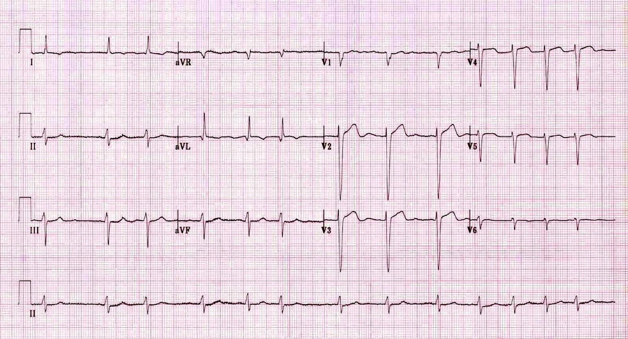  ECG source: https://i1.wp.com/lifeinthefastlane.com/wp-content/uploads/2012/01/af3.jpg?ssl=1 | CXR: normal  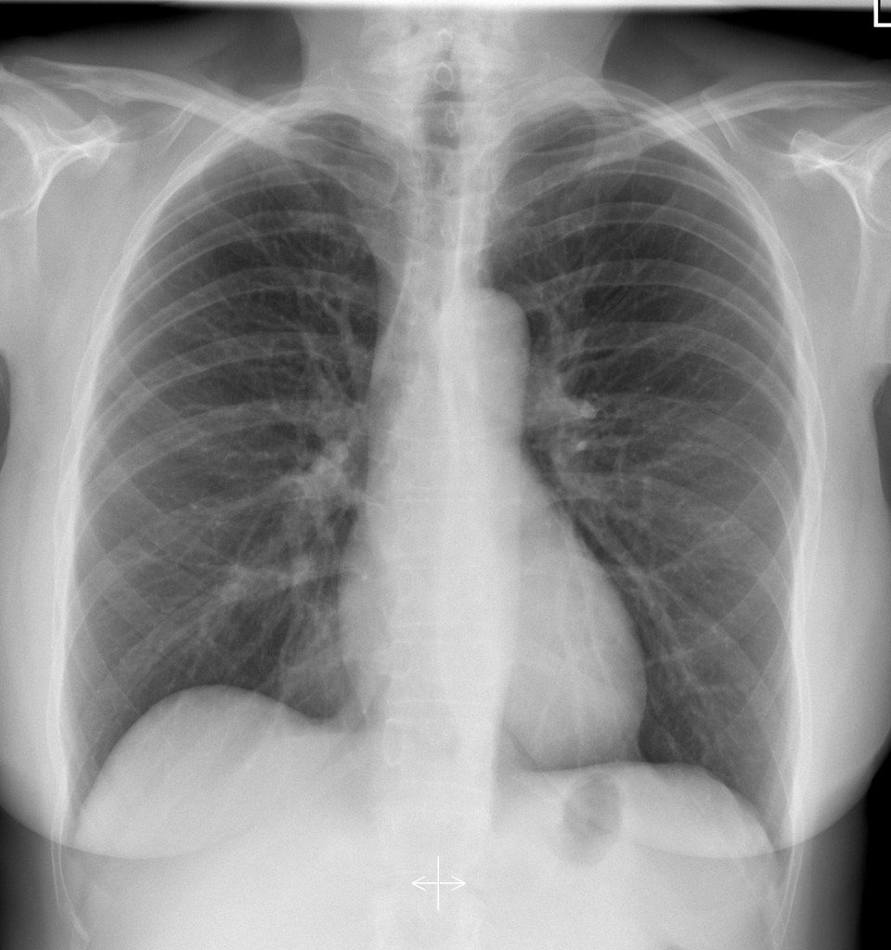  CXR source: https://radiopaedia.org/cases/normal-chest-radiograph-female-1
PXR: normal  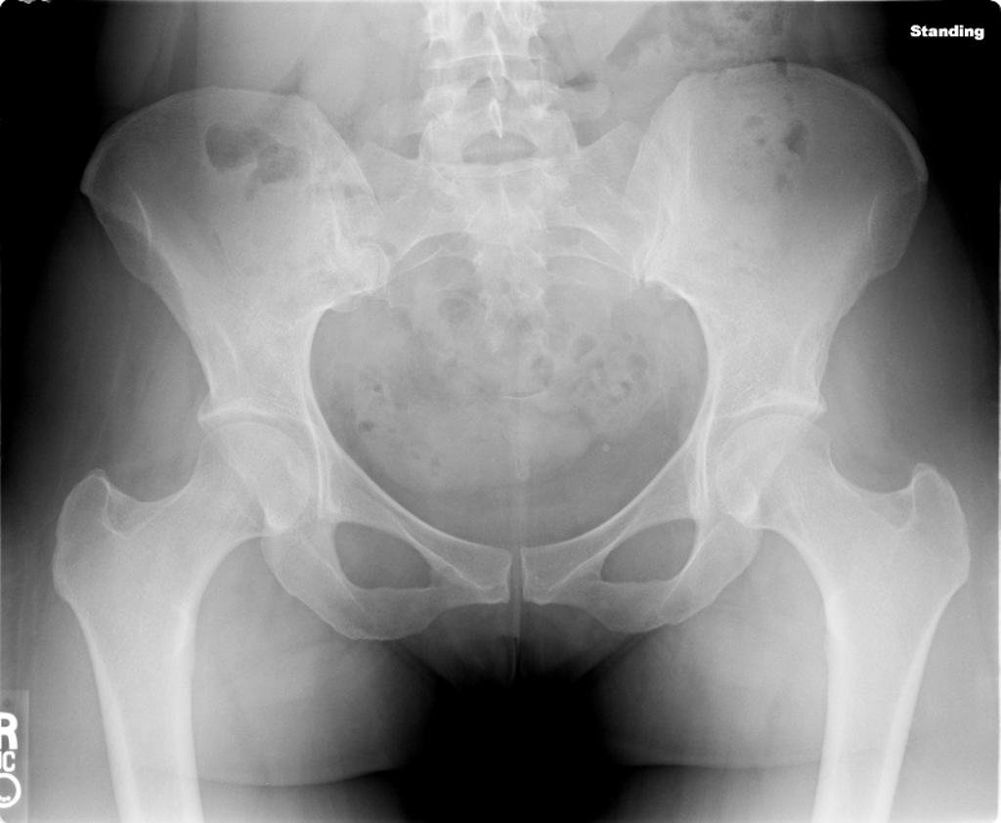  PXR source: https://radiopaedia.org/cases/normal-pelvis-x-ray-ap | RUQ FAST Image: Free fluid  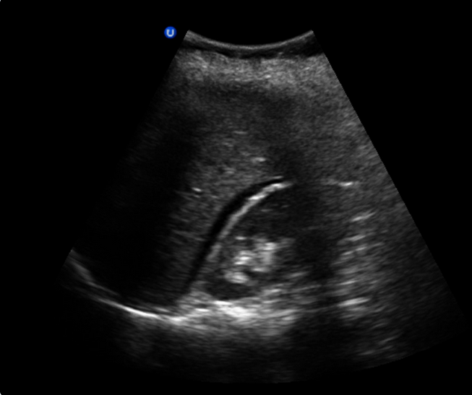  Image source: McMaster PoCUS Subspecialty Training Program

Section VIII: Debriefing Guide

General Debriefing Plan
Individual |  | Group | With Video | Without Video
Objectives
Educational Goal: | To practice focused assessment and management of an elderly patient presenting with a fall and to identify signs of elder abuse
CRM Objectives: | - Demonstrate an effective team-based assessment of a geriatric patient presenting with a fall  - Demonstrate a sensitive approach to a patient who is identified as a possible victim of elder abuse
Medical Objectives: | - Seek and treat causes and complications of geriatric falls  - Recognize the unique signs and symptoms of elder abuse  - Concurrently manage a patient’s complex medical and social issues
Sample Questions for Debriefing
CRM
- How did you organize the team to manage this patient effectively?
- What strategies did you use to effectively communicate with this patient to elicit the cause of their fall?
- How did you maintain awareness of both the patient’s acute medical issues and difficult social issues?

Medical
- What are the differences between elderly trauma patients and younger adult trauma patients?
- What were your management priorities in this patient?
- Falls in the elderly are multifactorial; tell us your approach.
- At what point did you make the conclusion that this might be an elder abuse case? Talk us through the signs and symptoms you have identified in this case to support elder abuse.
- What are some different types of elder abuse?
- What is the management of elder abuse?

Key Moments
- Identification that patient has significant intraabdominal injury after relatively minor trauma
- Identify elder abuse as cause of the trauma
- Concurrent management of patients complex medical and social issues

